HDNes Graphics Pack Editor Tutorial

HDNes Graphics Pack Editor is a tool for editing a HDNes graphics pack to be used on Mesen emulator. So far this tool is only tested with CHR-ROM games and may not work with CHR-RAM games.

Basic workflow:

1. Create a new project

Play the game once on Mesen with HD Pack Builder to create a folder with the hires.txt file. Make sure the correct scale is selected. Open the editor, choose “New Project” under “File” menu. Select the rom file and the location of the folder created.

1. Project structure

The left panel under the “Game Objects” tab is the project tree. Nodes with a “\” at the end of the name are folders and the others are object items or background items. Folders are used to group items together and can contain sub folders. All projects start with a root folder. Object items define tile replacements and background items define background image placement. Right click the folder node which a new node will be placed under. Select the node type to add the node. Double click the node name to edit the name.

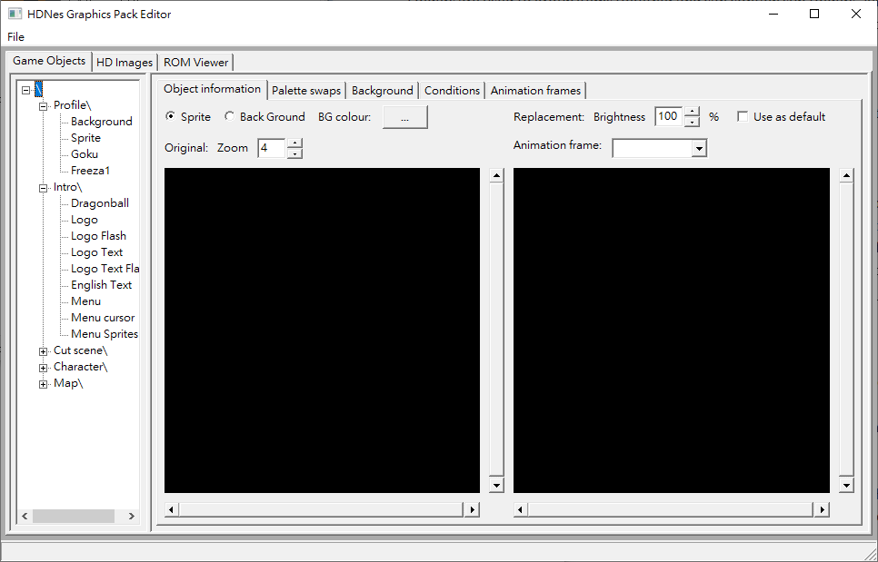

1. Working with a new object

After adding an object, select whether the object consists of sprite tiles or background tiles. For sprite tiles, select a background colour to show the tiles against. For background tiles, the background colour is determined by the colour 0 of the palette from the first batch of tiles added to the object. The background colour of background tiles cannot be changed once set so background tiles within the same object should all have the same background colour.

1. Retrieving tile information

When adding tiles, we need three pieces of information: tile data, palette and position. There are three ways of getting this information

1. Play the game until the point where the object can be seen on the screen (next frame to be exact). Pause the emulator and select “PPU Viewer” under “Debug” menu. For background tiles, under the “Nametable Viewer”, there will be 4 screen showing all the background tiles in the nametable. Hold the “Shift” key and right click a screen and choose “Copy Nametable (HD Pack Format)”. This will copy the tiles into the clipboard.

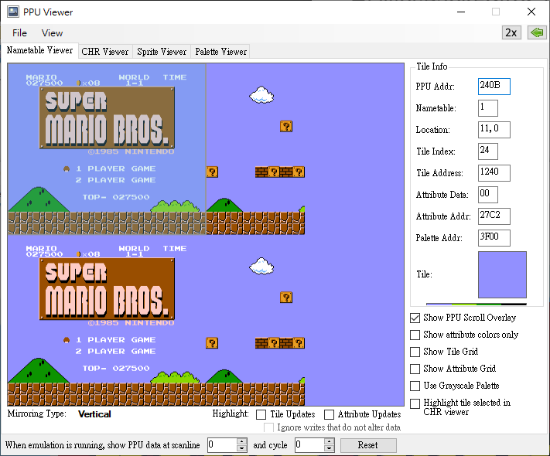

Similarly, for sprite tiles, go to the “Sprite Viewer” tab, hold the “Shift” key and right click at the bottom screen and choose “Copy All Sprites (HD Pack Format)”. This will copy the tiles into the clipboard.

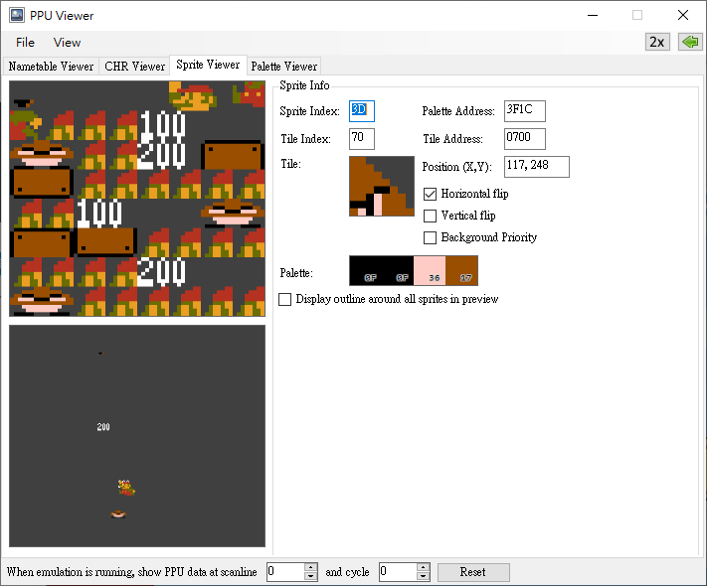

1. If the palette is known and the tiles are packed in the ROM in a relatively easy to organize order, it is possible to get the tile information without playing the game until all tiles are shown. A common use case is the game font. The letters are usually packed together in alphabetical order which is easier to work with than picking out each letter from sentences. After finding a letter in either nametable viewer or the sprite viewer, right click the tile without holding shift key and select “Copy Tile (HD Pack Format)”. Paste the content onto any text editor. It will be something like “100,2230210F”. The first part is the tile ID and is the location of the tile in the ROM and the second part is the HEX code of the palette. Under the “ROM Viewer” tab of the editor, type in the HEX code and scroll down to the where that tile is located. Highlight the tiles with the mouse, right click and select “Copy” to copy the tile information.

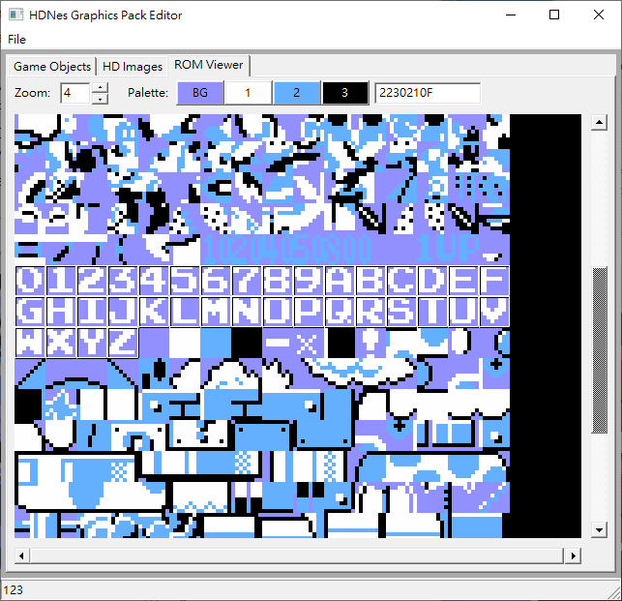

1. Use the screen data generated from Mesen. Please see point 8 of Advance Features section for further detail.
2. Adding tiles to an object

Under “Object Information” tab, right click the left black area and select “Paste” to add the tiles into the object. Often only some of the tiles belongs to the object, so select the tiles which are not needed, right click and select “Delete” to remove them. Tiles in an object can also be copied to other objects too.

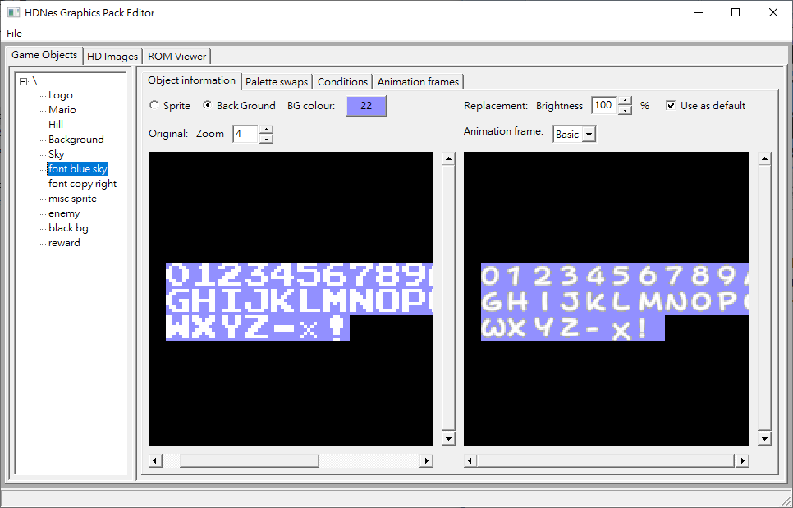

1. Adding images

Create images with the replacement graphics, go to the “HD Images” tab and add the images

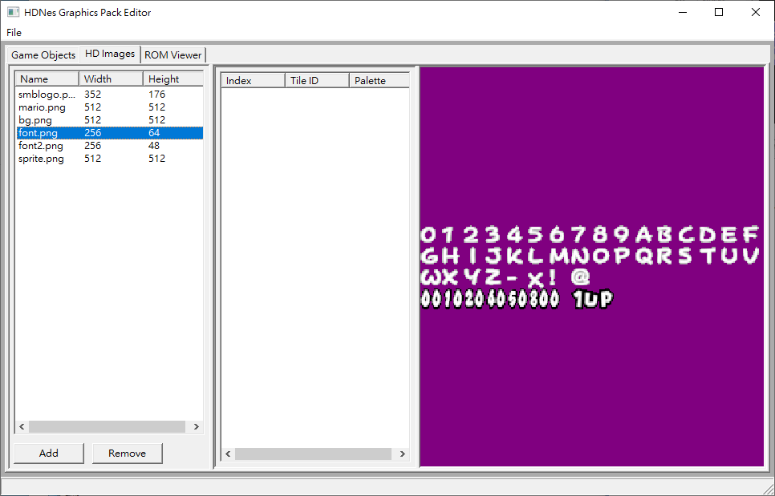

1. Assigning replacement to tiles

Highlight the tiles to be replaced in the left area under the “Object Information” tab.

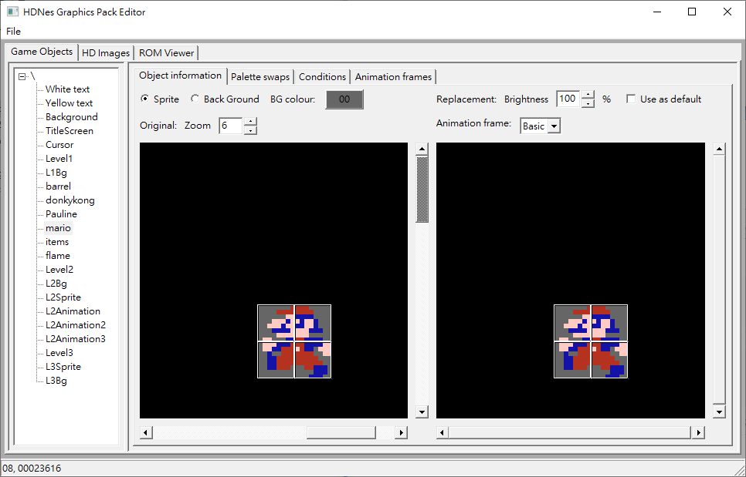

Right click and select “Set replacement”. A dialog box will be shown. Select an image from the drop down box and the dialog box will show the selected image. Click the location of the replacement tiles so that the tile boxes align with them. Click “OK” button to confirm the changes.

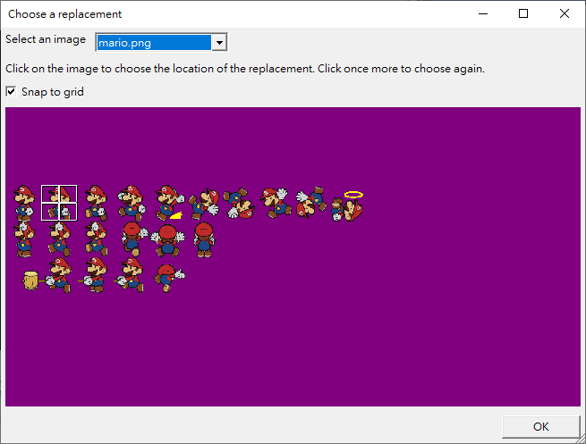

1. Saving the changes and updating the hires.txt file

Select “Save Project” under the “File” menu to save the project. The file uses “.hnp” as file extension. Select “Generate Pack Data” to create a hires.txt file. The old file will be renamed as backup. Sometimes a sprite tile may be flipped horizontally or vertically in an object. For example tiles of Mario in Donkey Kong are facing right in the ROM but the tile information is copied when Mario is facing left in the game.

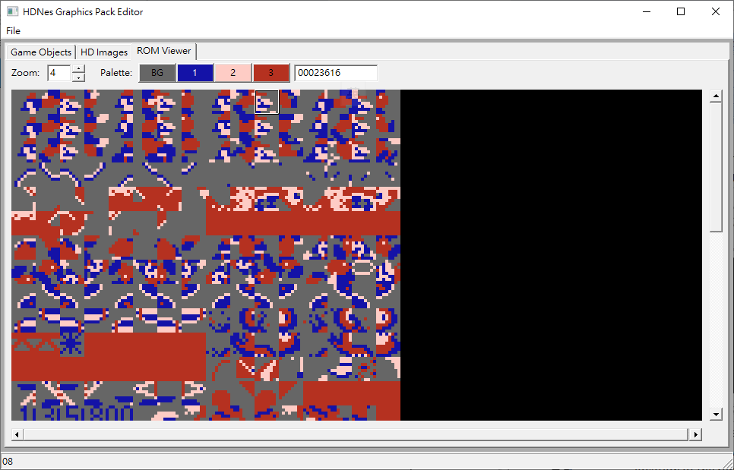

In this case, the editor will generate an image with the replacement tile flipped to the original orientation.

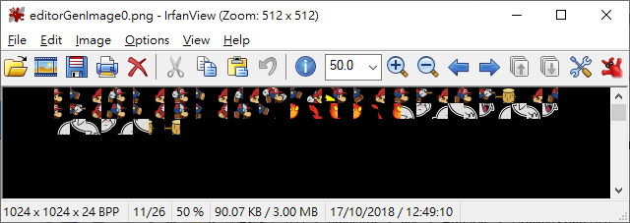

Advance Features:

1. Setting brightness of replacement tiles

When the replacement tiles need to be shown at less than full brightness, select the brightness % to apply that brightness to the all the tiles in the object.

1. Setting default replacement tiles

Sometimes the same replacement tile may be applicable regardless of palette. In this case, select the “Use as default” option under “Object information” tab.

1. Handling palette swaps

If a game uses palette swaps on objects, it may be sufficient the use the same replacement graphics with different colours. In this case, the editor can help by generating copies of the replacement tiles with a shift in hue or saturation and assign them to specific palettes. To add a palette swap to an object, after assigning replacement to the tiles, go to the “Palette swaps” tab. Set a name for the palette swap, select one palette from the list at the bottom and input the new palette. Then set how the replacement tile should be modified. The modification is a combination of changes in brightness, hue or saturation. Press the “Add” button to add the palette swap to the list at the top. A common use case is fade-in or fade-out of objects.

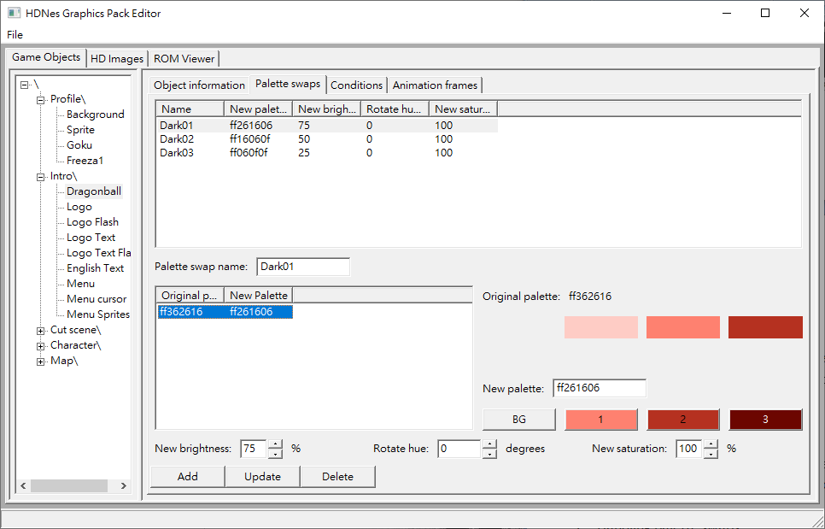

1. Assigning replacement base on nearby tiles

Sometimes tiles are reused in different situations and different replacement for each situation is preferred. For example the Mario’s body when standing still in Super Mario Bros is symmetrical, but the replacement for that part isn’t.

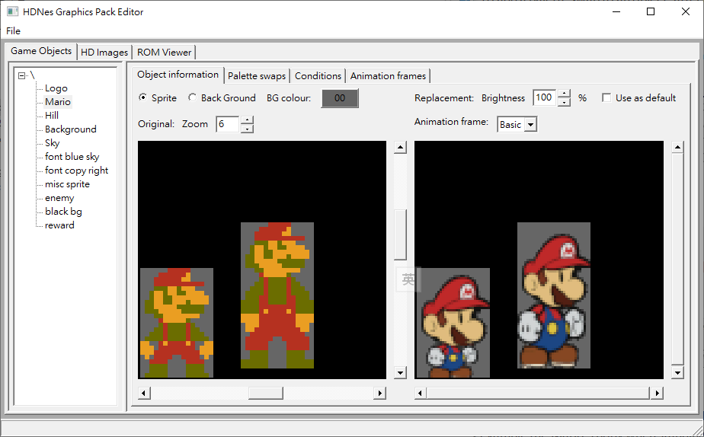

However, it is possible to identify with side the body is facing using the head tiles and use the head tiles as conditions to set the replacement. Highlight the tiles which share the same condition, right click and select “Set conditions for tiles”. Highlight the tiles to be used as conditions, right click and select “Confirm changes”.

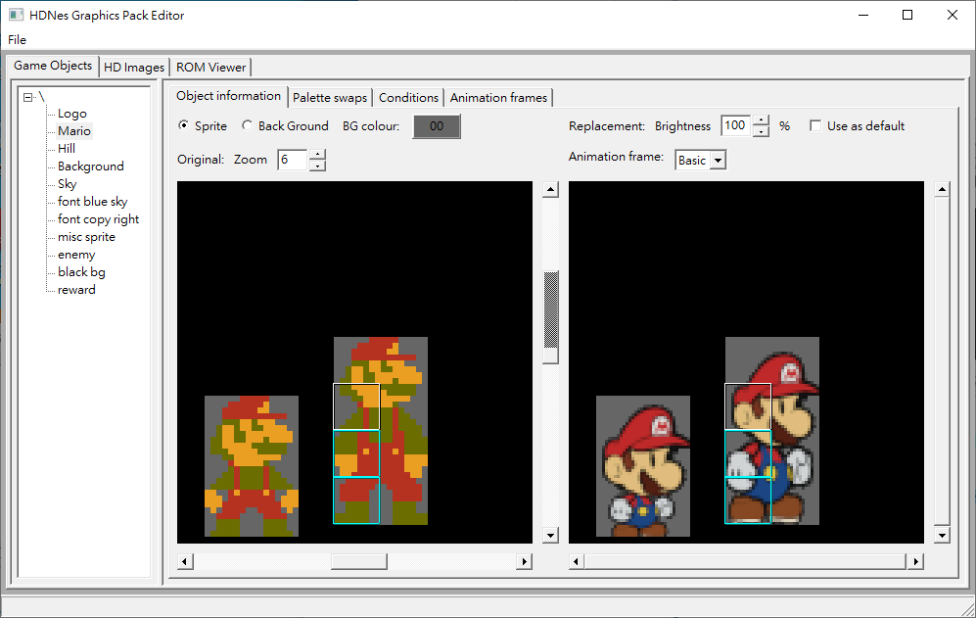

It is best to use as few tiles for conditions as possible, since conditions may break if the object is partially off screen and the tiles used in the conditions are off screen as a result.

It may be necessary to have more than one copy of those tiles and several sets of conditions to handle those cases.

1. Applying conditions to all the tiles in the object

There are other types of conditions which can be used. Rather than setting those conditions for each of the tiles in the object, the editor is limited to applying the condition to all of the tiles in the object. Go to the “Conditions” tab and add conditions there.

1. Redefine animation frames

For an object which is static or in looping animation, if the replacement is a looping animation which does not match to the original frame by frame then the frame range feature of the HD pack can be used to implement it. Go to the “Animation frames” tab, there will be a frame named “Basic” of display length of 1 by default. Add other frames to the list and set the display length for each frame.

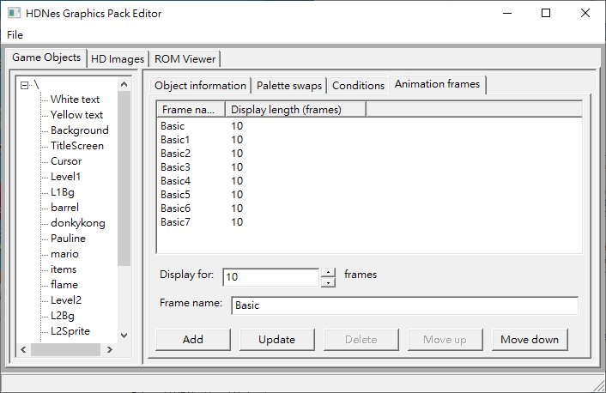

Then under the “Object information” tab, select each animation frame in turn and assign replacement for each.

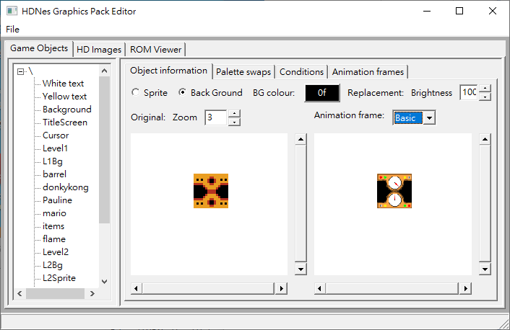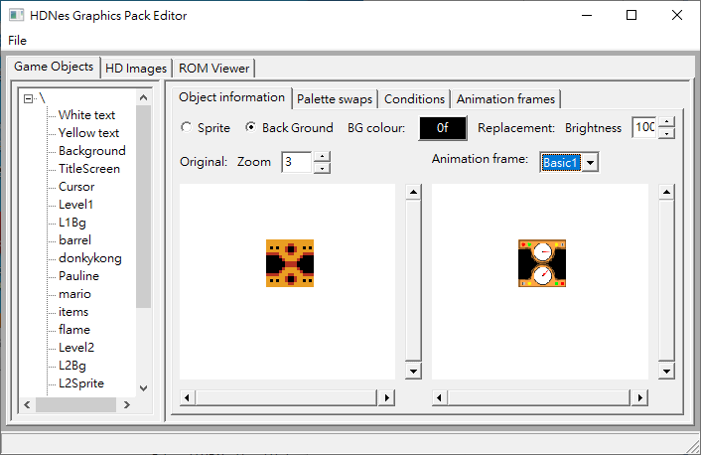

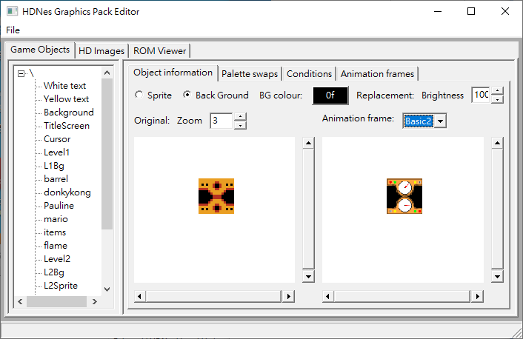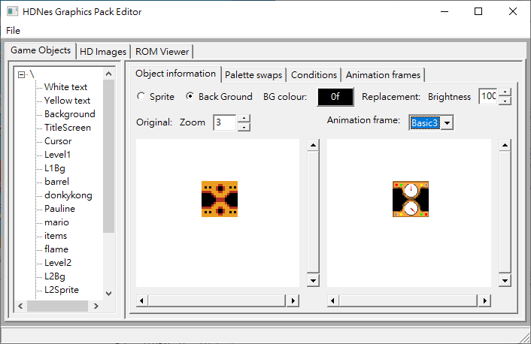

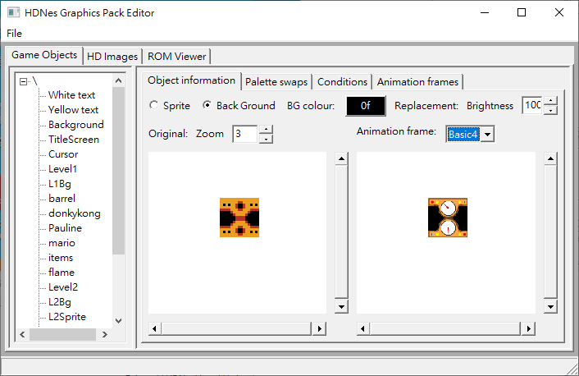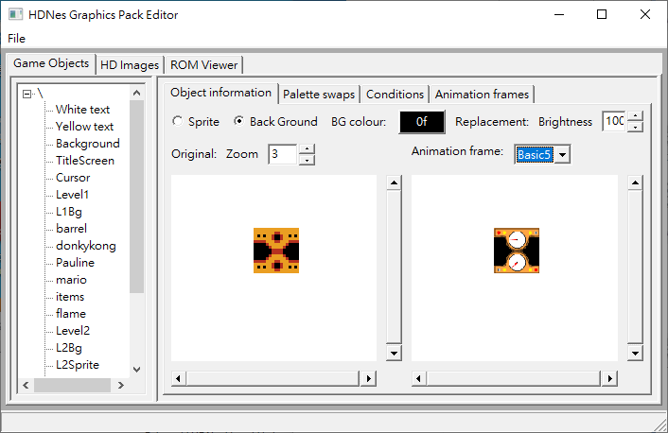

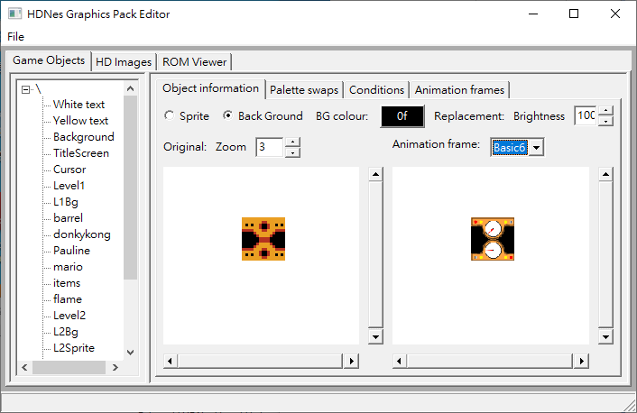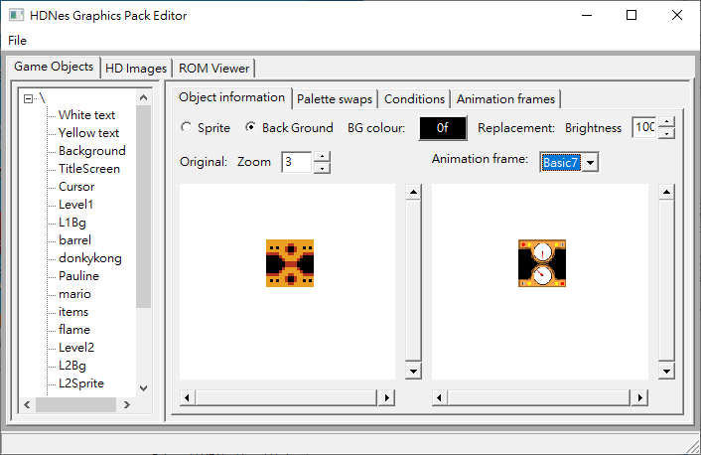

1. Displaying an image in the background

Add a background item to the project. Click the “Select image file” button and select one of the images to be the background image. Adjust settings as needed and add conditions to control when the image is to be shown. For example, the existence of the number “2” at a specific location on the screen indicates the player is at level 2 and the a background image specific to level 2 is shown.

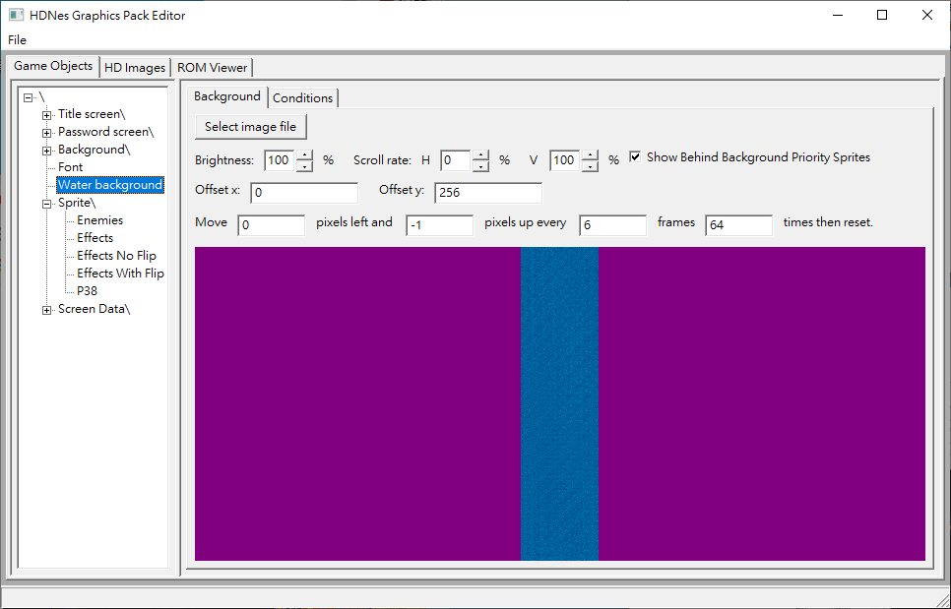

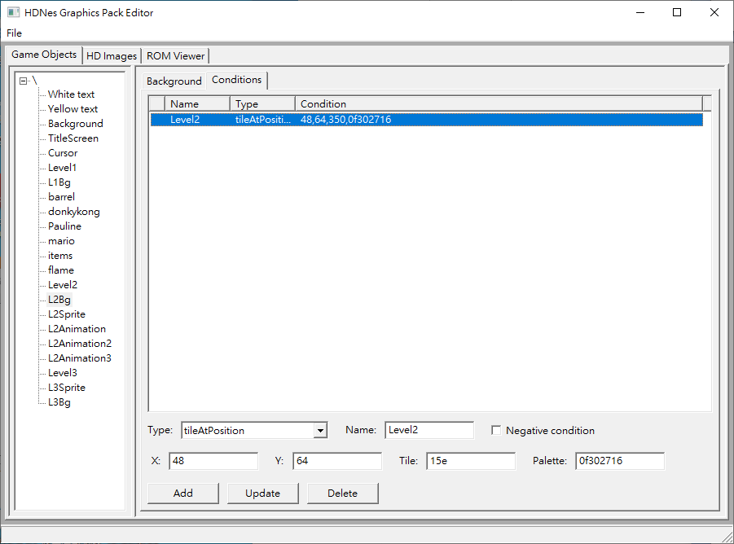

1. Use screen data generated from Mesen

Use HD Pack Builder tool of Mesen with the “Save frames which the tiles are first shown” option selected. The builder will dump the screen information into the pack folder which this editor can load into the project under the “Screen Data” folder. The editor will load the data when the project is first created. Right click the folder and select the “Remove redundant screens” option to removing screens which do not contain any unique tile. The screens are listed as sprite objects with “sp” suffix in the object name and background objects with “bg” suffix n the object name. The tiles in these objects can be used to create other objects.

